CSC506 Module 1 Critical Thinking

Michael McPherson
Colorado State University, Winter-B
CSC506-1 Design and Analysis of Algorithms
Module 1
Dr Luis Gonzalez

15 December 2024

Introduction:
A sequential, or linear, search algorithm is a straight forward method to check each piece of data in a list. It does this sequentially until one ofr two things happen: a match is found or the search has checked each piece of data. This paper briefly summarizes the use of a linear search algorithm to check for an item in a stores online database,

The Algorithm:
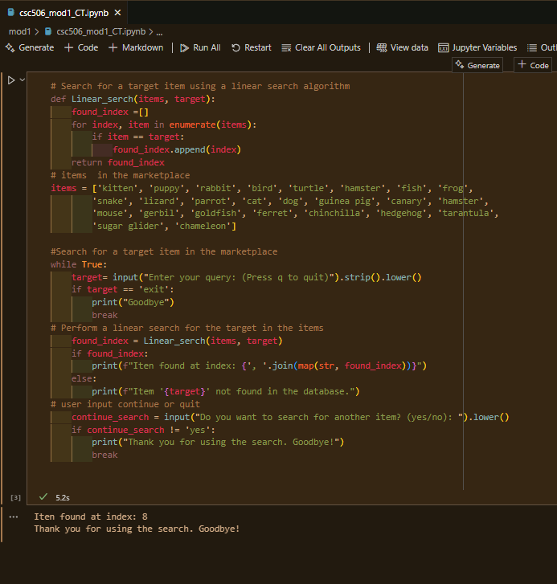

The Linear Search Algorithm (LSA) reads the list ‘items’ starting at the first index position, then iterates through the entire data structure looking for a match with the user entered ‘target’. The algorithm will stop when it has either found a match, or has iterated through the entire structure. In this particular case the data structure is a list of pet types for an online pet store.
Time Complexity:
The Time Complexity (TC) of a LSA is calculated by the function O(n), where ‘n’ is the number of items in the database. The ‘O’ is called “Big O notation” and it is a standard function name, used in mathematics when calculating TC (Scholarhat.com). This means This means the search time increases linearly with the size of the data set. In large databases typical of online marketplaces, this can lead to significant delays, making linear search less efficient compared to more sophisticated algorithms like binary search of hashing.
Data Structure:
The size and type of the Data Structure are significant influences on the performance of the LSA. When using an Array which is common, the LSA will use the index and cycle through the database. In worst case scenarios, every index and data-point will have to check the entire dataset.
Other Factors:
Data structure and size are not the only hindrances to efficiency with an LSA. Some of the others ‘Item distribution (ID)” and ‘System Load (SL)’. ID will speed up the algorithms outputs if the query is in the front of the database. Whereas, SL will hinder LSA performance if the database is buy pulling other requests and data.
Conclusion:
While the LSA is simple to create, code and implement; it is easy to understand its practicality is greatly reduced on large scale especially when it is going to be used for a large online retailer. Being as such the other two algorithms mentioned above may be better suited for the task.

References:
Author. (2024, October 9). Understanding Time Complexity In Search Algorithms.
Peerdh.com.
https://peerdh.com/blogs/programming-insights/understanding-time-complexity-in-search-algorithms
Linear Search in Data Structures - Algorithm, Working, & Complexity.
(n.d.). Www.scholarhat.com.
https://www.scholarhat.com/tutorial/datastructures/linear-search-in-data-structures
Pressman, R. S., & Maxim, B. R. (2020). Software engineering : a practitioners approach. Mcgraw- Hill Education.

